**PRESS RELEASE – EMO 2019**

**Danobat presents its solutions in precision & digitisation at the EMO in Hanover**

* Machine-tool and production system manufacturer Danobat is to show its latest generation developments in hard materials turning & grinding technologies, which guarantee high precision, reliability and productivity.
* The firm is to have its own 700 m² stand at the event, where it will showcase its broad range of value-added services and the consolidation of its digital and automation technologies.

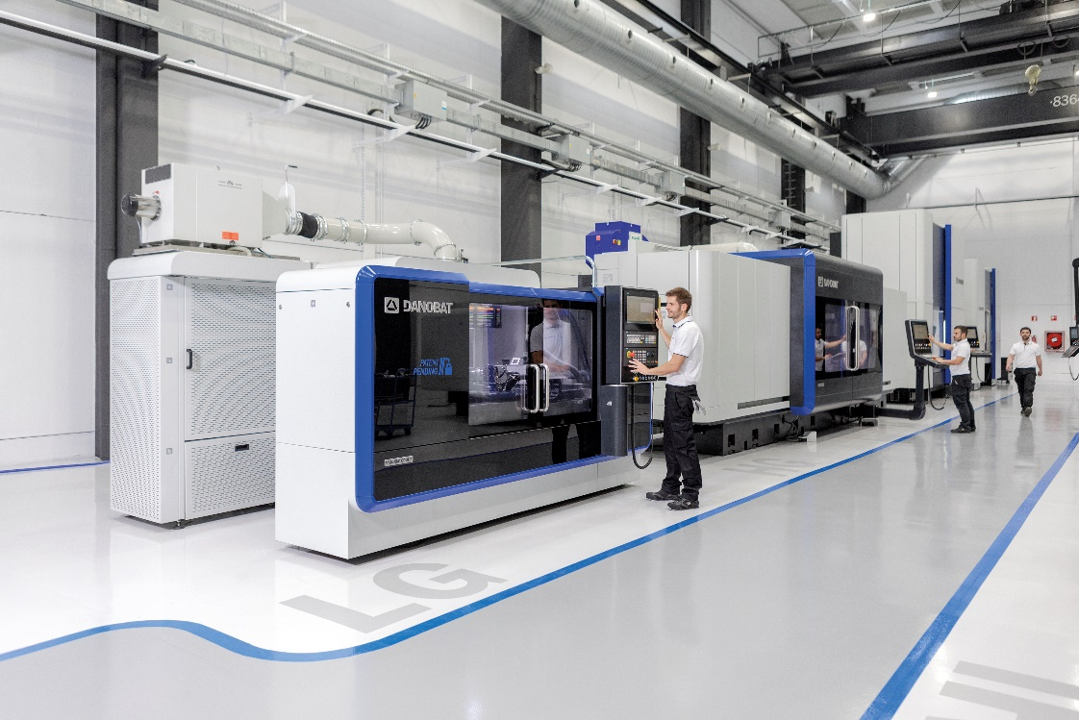

Machine-tool and advanced production systems manufacturer [Danobat](http://www.danobat.com) will once again have a major presence at this year's [EMO](https://www.emo-hannover.de/home) trade fair in Hanover, one of the biggest events on the international calendar for the industrial manufacturing sector.

Under the slogan "Together beyond Challenges", the firm is to present eight latest-generation machines with high technology value, three of them fully automatic, designed to handle high precision turning and grinding processes. Danobat will also be showcasing its development of advanced services and the consolidation of its digital value services.

The firm is to have 700 m² of exhibition space (stand D-45, Hall 11), where it will present solutions developed to make industry more competitive and adjust fully to the machining needs of its customers while guaranteeing maximum reliability and productivity in highly demanding applications.

"Seeking to continue fostering competitiveness at our partners and optimising manufacturing processes, we have developed a range of high-precision grinding machines that run from universal configurations to the toughest, most highly customised machines. These solutions have been designed in close cooperation with their end users. They are complete developments that include not just machinery but all the accessories and processes associated with the goal of making our customers more competitive", says Danobat CEO Xabier Alzaga.

**Cutting-edge technology solutions**

Specifically, at this edition of the EMO Danobat is to present a fully automated system for grinding the injector seal on automotive engines, a component barely 2 mm in diameter for which production demands are very high.

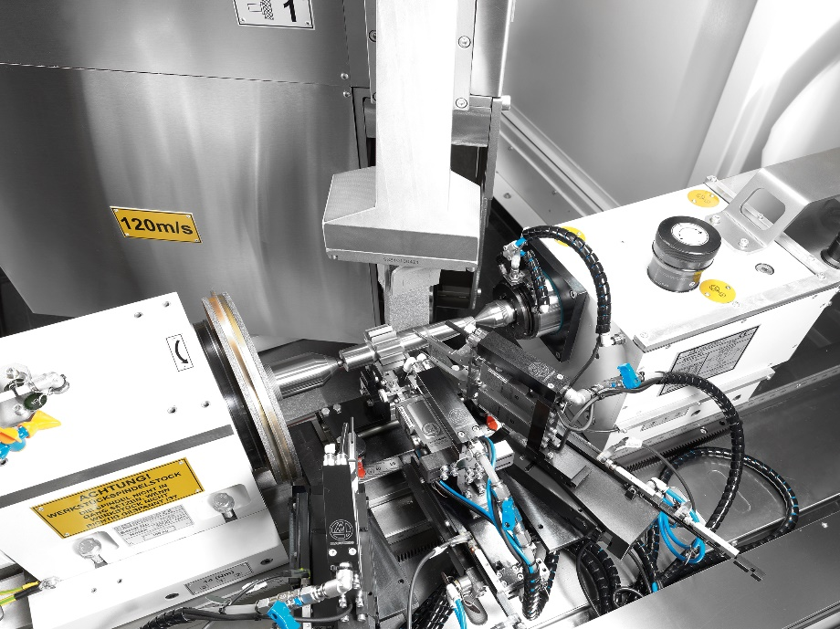

The firm is also to show its LG-1000 exterior grinding machine with built-in gantry, a development that combines great flexibility (it is capable of manufacturing up to 180 different items) with high production capacity.

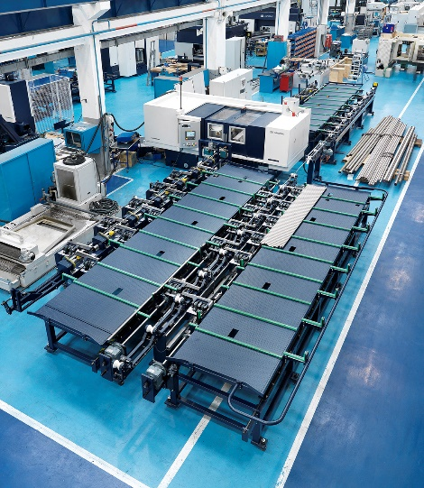

The EMO will also feature the presentation of the ESTARTA-650 centreless grinding machine, intended to manufacture components for electric bikes, and the HG-72 grinding machine, which has been redesigned to manufacture components 1500 mm in length for electric motors made by Siemens and now integrates grinding and measuring operations in a single set-up.

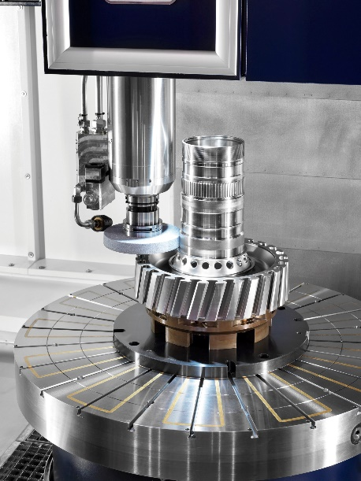

Another new product which Danobat will be showing at the trade fair is the VG-800 vertical grinding machine, which combines exterior and interior grinding and measuring operations for the manufacturing of precision machine-tool components.

To cater for users who need the precision provided by grinding machines but do not wish to forsake the flexibility of turning machines, the firm is to present a high precision lathe for turning hard materials, with a system aimed at meeting the needs of short-run manufacturers who need to change the type of component made frequently.

Along with these new machines, the firm's stand is to showcase two grinding machines made by its German subsidiary [Danobat-Overbeck](http://www.danobatgrinding.com): the IRD-400, a fully automatic machine using a robot to load and unload workpieces, intended specifically for grinding interiors and spokes; and the ILD-400, designed to grind interiors, exteriors and spokes and for non-cylindrical grinding on workpieces measuring up to 1300 mm in length.

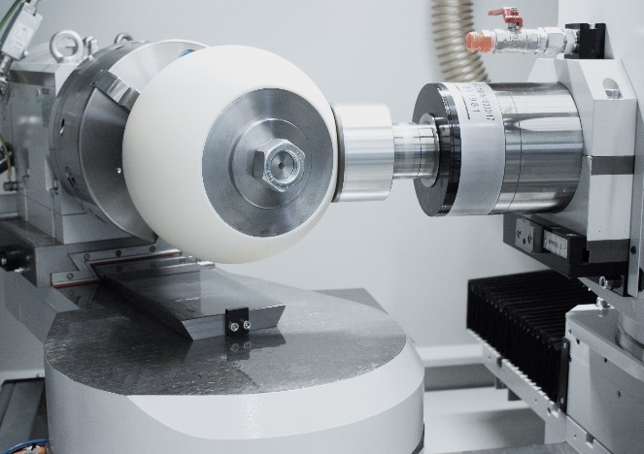

During the trade-fair Danobat is also planning to present its new "multi-frame" machine interface, which can be user customised to combine different windows on the HMI for more user-friendly browsing.

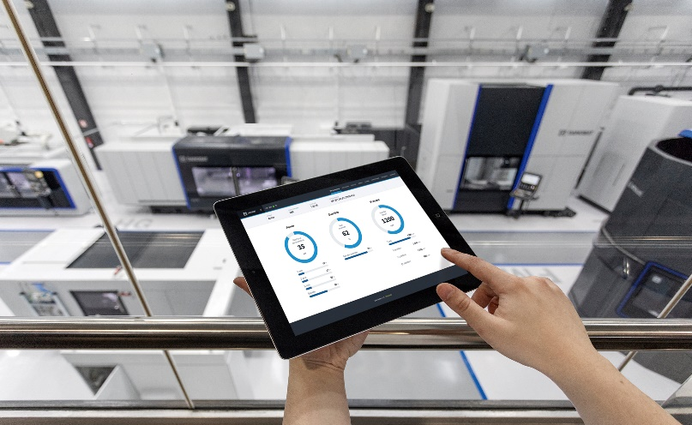

**Sights set on Germany**

Innovation is a key part of all the solutions provided by Danobat and is an essential requirement in meeting the demands of the German market, which is the company's second-biggest in terms of total sales. Along with its importance to Danobat in terms of sales targets, Germany plays a determinant role in the company's strategy, as it is a country with great influence on the surrounding markets.

"The German market is highly demanding in technological terms, which means that we must always be at the cutting edge of innovation. 87% of our projects involve a design tailored to the needs of the customer, which means that there is a component of innovation in all our solutions. Indeed, 35% of our sales come from solutions that did not exist four years ago. This makes Danobat an ideal manufacturer for meeting the requirements of the highly demanding German industrial sector ", says Mr. Alzaga.

The firm's stand-out projects in Germany include a recently developed solution for high-precision grinding of Curvic teeth for the aerospace industry. Another development that illustrates the importance placed by Danobat on the German market is the recent installation of three cells for dry grinding and subsequent checking of carbon rotors for hydraulic pumps for the automotive industry.

**From solutions to services**

Along with these latest-generation solutions, Danobat will also be publicising its broad range of advanced services and the consolidation of its industrial digitisation service.

The EMO in Hanover is the setting selected by the firm for the presentation of its "MyDanobat" platform, a new portal which is already in use among its customers and which provides users with greater control and knowledge of their machines based on specific functions.

The “MyDanobat” platform enables users to access historical data on services performed on machines, technical documentation, training sessions in the form of tutorials, manuals, backups and reports.

"Our ability to develop digital technologies and tools means that we can offer a range of services to help make our customers more competitive based on knowledge of machine behaviour, thus meeting the challenges of the industry of the future", concludes Mr. Alzaga.

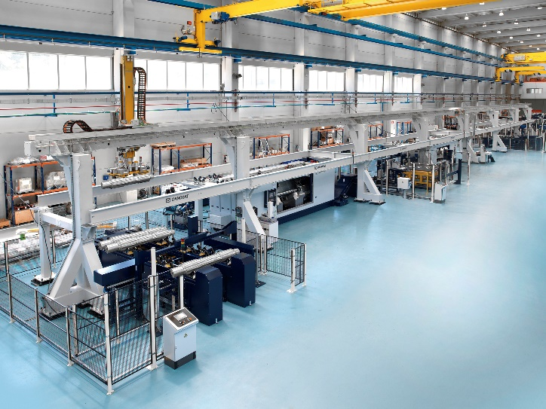

Some of the solutions presented at the EMO feature sensors, opening up the door to customised plans for preventive maintenance on key machine components in line with the needs of each customer. But predictive maintenance strategies can also be implemented via smart algorithms which compile data via continuous machine status monitoring and apply self-learning processes capable of detecting potential operational anomalies before they occur.

The EMO is scheduled to take place in Hanover on 16-21 September, and will bring together over 2200 exhibitors at a 180,000 m² venue.

**About DANOBAT**

Danobat develops machine-tools and advanced production systems for high technology sectors and customers with high-level technical requirements.

It offers a range of advanced machines with guaranteed high precision, reliability and productivity, designed to tackle even the toughest machining processes. The company develops advanced systems for the manufacturing of high value-added components and works in close cooperation with leading firms in its sector to create fully automated lines and end to end solutions covering the whole process from design through manufacturing and the full useful lifetime of each solution.

It is strongly internationalised, with production plants in Spain and Germany, along with centres of excellence in those same countries and in Italy, the USA and China.

Danobat is part of the [Danobatgroup](https://www.danobatgroup.com/es), an industrial group with 1300 employees which invests 8% of its turnover in R&D&i projects.